Interrogative Adverbs

🔹 What Are Interrogative Adverbs?
# Source: AI Source: Provided by: [Data Path: Persons Table -> ID Column: 1, Name_En Column: Motasem Essam] -> From: [Chatgpt (GPT-4-turbo)] on [7/27/2025]
Interrogative adverbs are used to ask questions about time, place, reason, or manner.
They begin questions and help gather information about an action.
They modify the verb in the sentence and are usually found at the beginning of a question.

✅ Common Interrogative Adverbs
# Source: AI Source: Provided by: [Data Path: Persons Table -> ID Column: 1, Name_En Column: Motasem Essam] -> From: [Chatgpt (GPT-4-turbo)] on [7/27/2025]
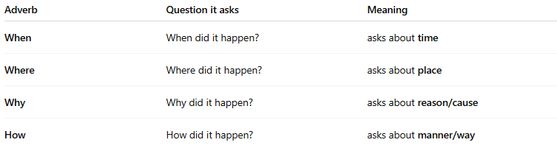
Adverb | Question it asks | Meaning
When | When did it happen? | asks about time
Where | Where did it happen? | asks about place
Why | Why did it happen? | asks about reason/cause
How | How did it happen? | asks about manner/way

📚 Examples in Sentences
# Source: AI Source: Provided by: [Data Path: Persons Table -> ID Column: 1, Name_En Column: Motasem Essam] -> From: [Chatgpt (GPT-4-turbo)] on [7/27/2025]
- When will you arrive?
- Where is your bag?
- Why are you crying?
- How does this machine work?

🧠 Key Notes
# Source: AI Source: Provided by: [Data Path: Persons Table -> ID Column: 1, Name_En Column: Motasem Essam] -> From: [Chatgpt (GPT-4-turbo)] on [7/27/2025]
- They are used to form questions (direct or indirect):
Direct: Why are you late?
Indirect: Tell me why you are late.
- These are adverbs, not pronouns, because they modify verbs, not nouns.

